50-State Business Tax Revenue Intelligence Dashboard (2015–2025)
Project Overview
The 50-State Business Tax Revenue Intelligence Dashboard is an end-to-end business intelligence project designed to analyze business tax revenue, tax burden, and tax competitiveness across all 50 U.S. states from 2015 through 2025. The project integrates multiple government and public datasets into a centralized analytical model to support executive decision-making related to business expansion, tax planning, revenue analysis, and multi-state tax strategy.
Using automated data preparation, SQL data modeling, and interactive Power BI dashboards, the project transforms complex tax data into actionable business insights that enable executives, tax professionals, and business analysts to evaluate state tax environments and identify opportunities for strategic investment.
Business Objectives
• Which U.S. states generate the highest business tax revenue, and how has busness tax revenue changed from 2015–2025?
• Which U.S. states exhibit the highest and lowest business tax burden, and how do sales tax rates and corporate income tax rates vary across states?
• How has U.S. business tax revenue evolved from 2015 to 2025, and what are the annual and quarterly growth patterns?
• How is business tax revenue distributed among property tax, sales tax, and corporate income tax, and how does the tax composition vary across states?
• Which states are most tax competitive for business expansion, and which states present the highest tax burden risk?

Project Architecture
Public Data Sources
│
▼
Python ETL
(Data Cleaning & Automation)
│
▼
SQL Server
(Data Warehouse)
│
▼
Power BI
(Interactive Dashboards)
│
▼
Executive Business Insights
Data Sources
The project integrates multiple publicly available datasets to provide a comprehensive view of state business taxation.
- U.S. Census Bureau – Annual Survey of State Government Tax Collections (STC) (2015–2025)
  - Property Tax Revenue
  - Sales Tax Revenue
  - Corporate Income Tax Revenue
- U.S. Census Bureau – Quarterly Tax Revenue (QTAX) (2015–2025)
  - Quarterly business tax collections for trend and seasonality analysis
- Tax Foundation
  - State Sales Tax Rates
  - State Corporate Income Tax Rates
- U.S. Census Bureau – Population Estimates (2015–2025)
  - Population by state for Revenue per Capita analysis
Technologies Used
Python (Data Engineering & Automation)
Python was used to automate the data preparation process, including:
- Automated cleaning of 44 QTAX Excel files
- Automated cleaning of remaining Census tax datasets
- Cleaning Tax Foundation tax rate datasets
- Combining annual population datasets
- Standardizing inconsistent file formats
- Preparing datasets for SQL Server integration
Libraries Used
- pandas
- openpyxl
- glob
- os
- re
SQL Server (Data Warehouse & Data Modeling)
SQL Server was used to design the analytical data model by:
- Importing and combining all cleaned datasets
- Automatically loading all 44 QTAX files
- Creating the final business tax fact table
- Building SQL views for reporting
- Creating calculated business metrics, including:
  - Business Tax Revenue
  - Tax per Capita
- Preparing optimized datasets for Power BI
Power BI Desktop (Business Intelligence)
Power BI was used to build an executive-level interactive dashboard consisting of five analytical pages.
Key Power BI techniques included:
- DAX Measures
- KPI Cards
- Filled Maps
- Line Charts
- Bar Charts
- Scatter Plots
- Donut Charts
- Interactive Slicers
- Dynamic Filtering
- Year-over-Year Growth
- Compound Annual Growth Rate (CAGR)
- Revenue per Capita Analysis
- Tax Competitiveness Analysis
Dashboard Insights
The dashboard provides five business-focused analytical views.
Executive Overview
Provides a national overview of business tax revenue by highlighting:
- Total Business Tax Revenue
- Revenue Growth
- Revenue per Capita
- Geographic revenue distribution
- Highest and lowest revenue-generating states
Tax Burden Analysis
Compares state tax environments by analyzing:
- Sales Tax Rates
- Corporate Income Tax Rates
- Overall Business Tax Burden
- State competitiveness differences
Revenue Trends
Evaluates long-term business tax performance using:
- Annual Revenue Trends (2015–2025)
- Quarterly Revenue Trends
- Year-over-Year Growth
- Compound Annual Growth Rate (CAGR)
Tax Composition
Breaks business tax revenue into major tax categories:
- Property Tax
- Sales Tax
- Corporate Income Tax
The dashboard identifies how each state's revenue structure differs and which tax categories drive overall collections.
Business Insights
Ranks states based on tax competitiveness to identify:
- Most attractive states for business expansion
- Highest tax burden risk states
- State tax competitiveness comparisons
- Strategic investment opportunities

Business Value
This dashboard transforms large volumes of public tax data into actionable business intelligence that supports strategic decision-making.
Organizations can use these insights to:
- Evaluate state tax environments before expanding operations
- Compare business tax burdens across all 50 states
- Monitor long-term revenue trends
- Improve tax planning and forecasting
- Support location selection and investment decisions
- Understand how different tax structures affect business operations
For tax professionals, accountants, and business analysts, the dashboard provides a centralized analytical platform for exploring multi-state tax data without manually consolidating information from multiple government sources.
Key Outcomes
- Developed an automated ETL process using Python to clean and standardize multiple public datasets.
- Built a SQL Server data warehouse integrating annual, quarterly, tax rate, and population data.
- Designed an interactive Power BI dashboard with five executive-level analytical pages.
- Applied DAX to calculate business performance metrics, including Business Tax Revenue, Revenue per Capita, Year-over-Year Growth, and CAGR.
- Delivered a decision-support tool that enables executives and tax professionals to evaluate business tax environments, compare state competitiveness, and support data-driven expansion and tax planning decisions.

Page 1 – Executive Overview
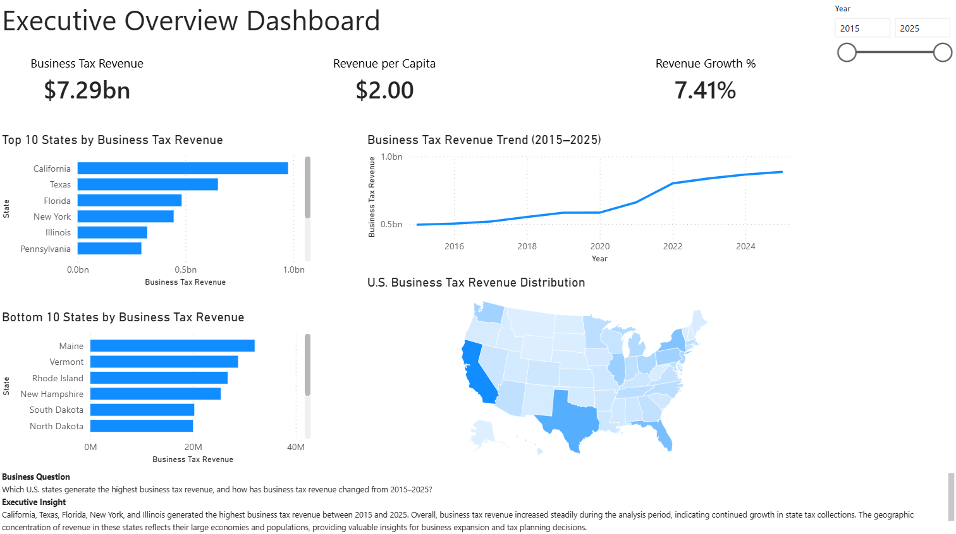

Page 2 – Tax Burden Analysis
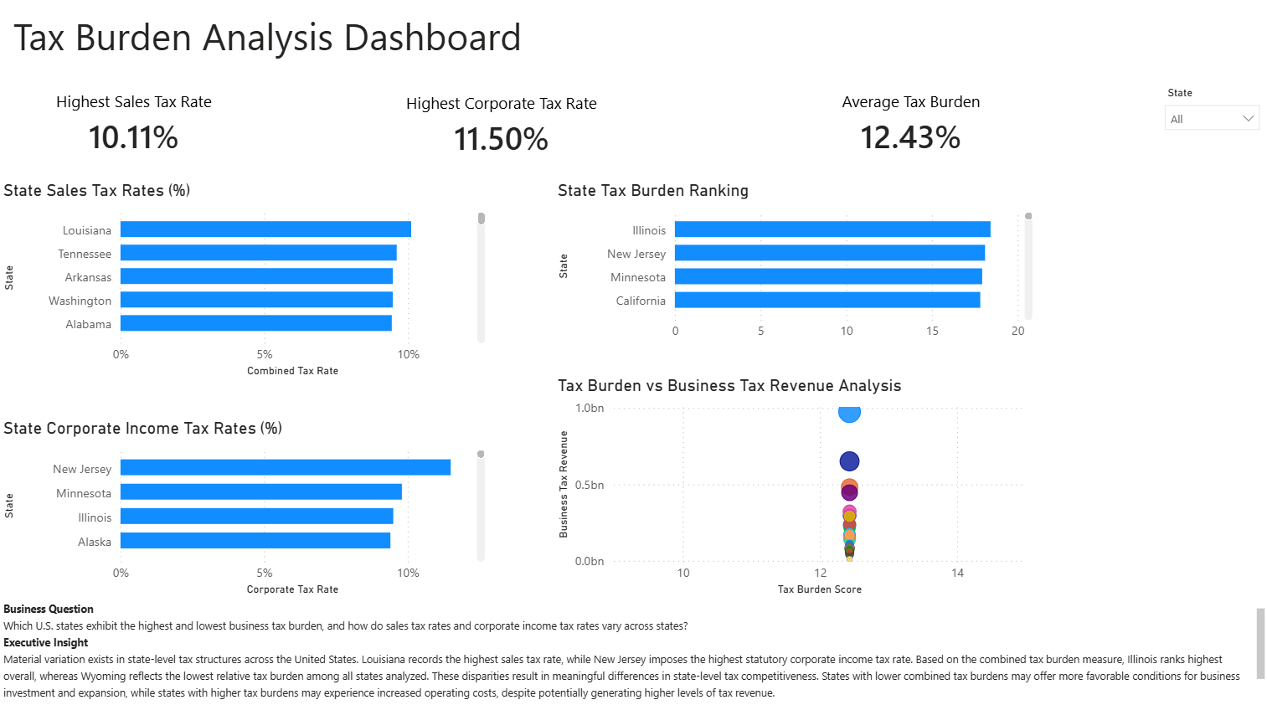

Page 3 – Revenue Trends
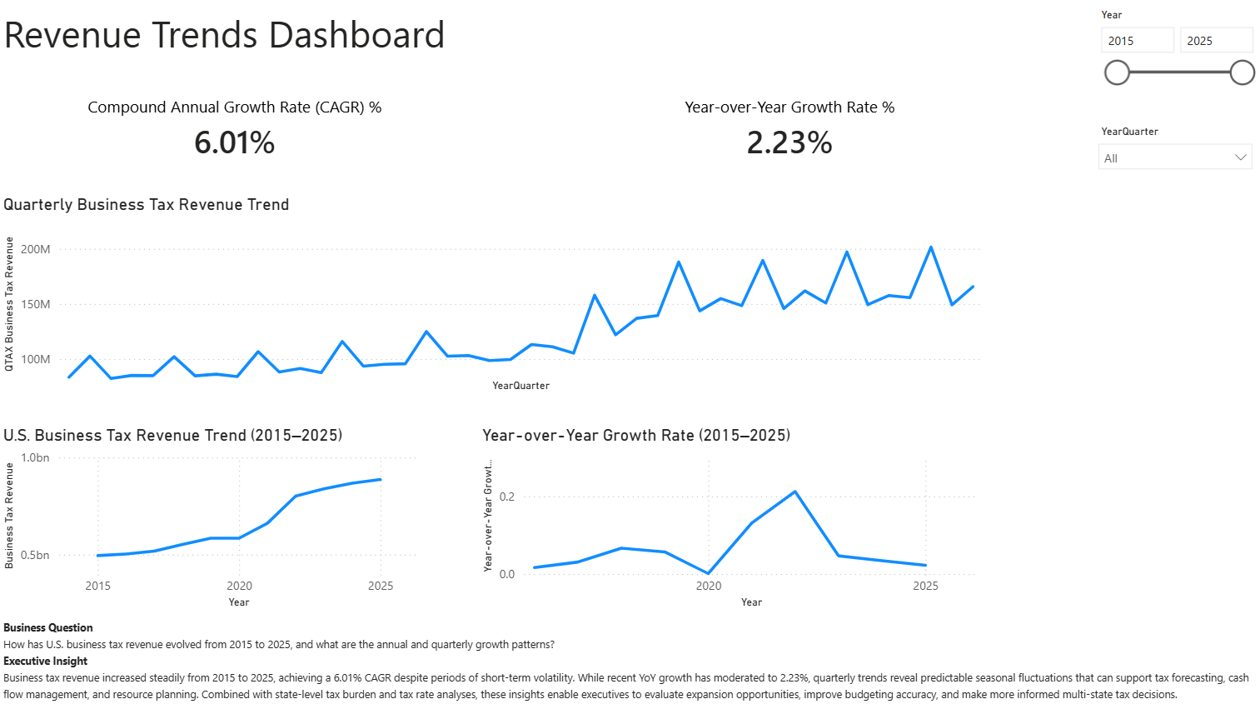

Page 4 – Tax Composition
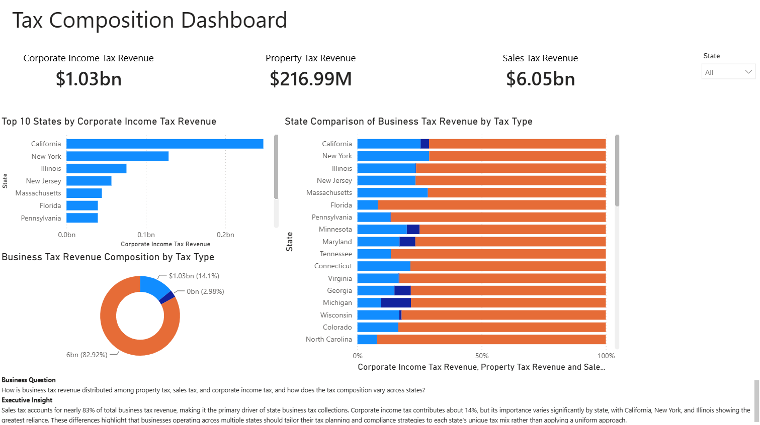

Page 5 – Business Insights
